Shared by: Greg Chou

If you are annoyed by TortoiseSVN default merge tool, maybe you can try this one ~~~

1. Installation:

[\\192.168.204.10\7000 erp技術部\Public\Tools\develop\p4vinst64.exe](file:///\\192.168.204.10\7000%20erp技術部\Public\Tools\develop\p4vinst64.exe)

* Select “Visual Merge Tool”

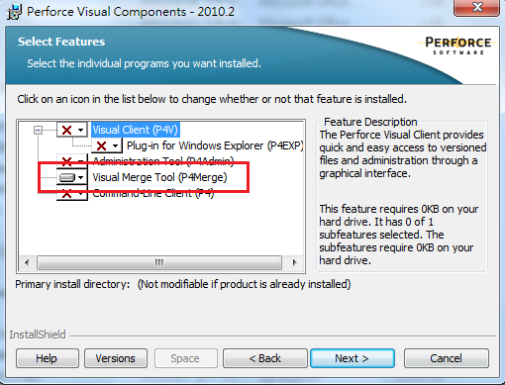

1. Setting for TortoiseSVN

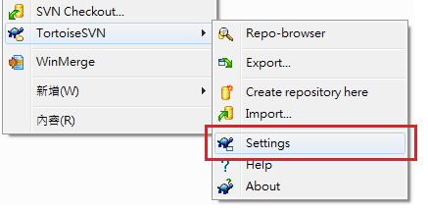

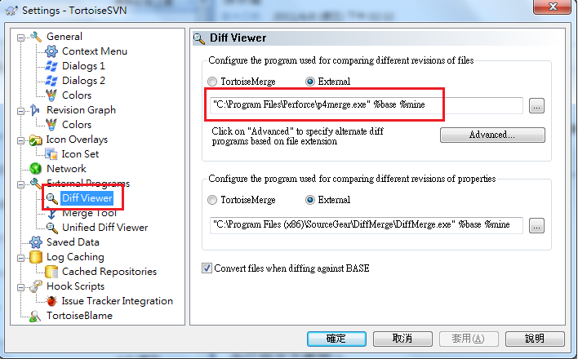

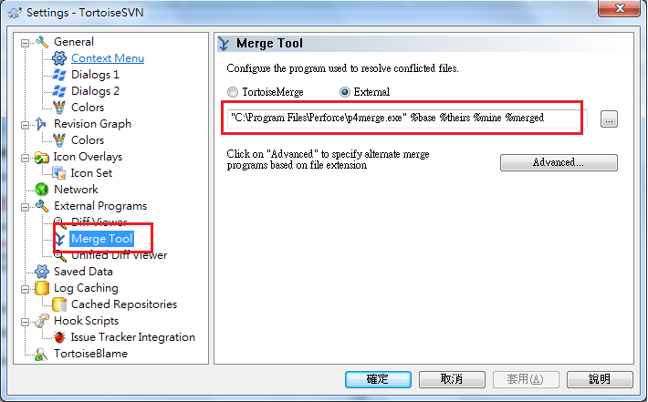

1. Diff screenshot

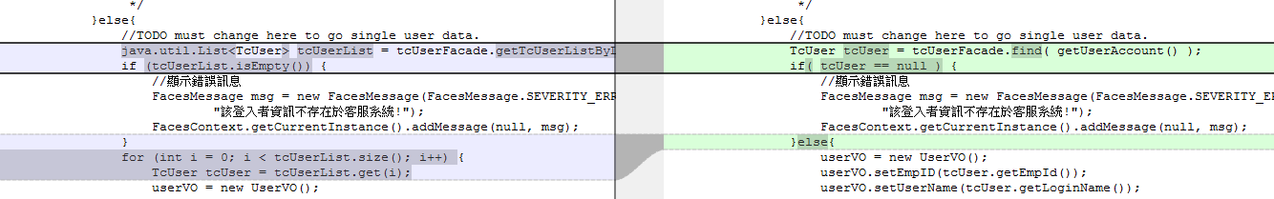

1. Merge screenshot

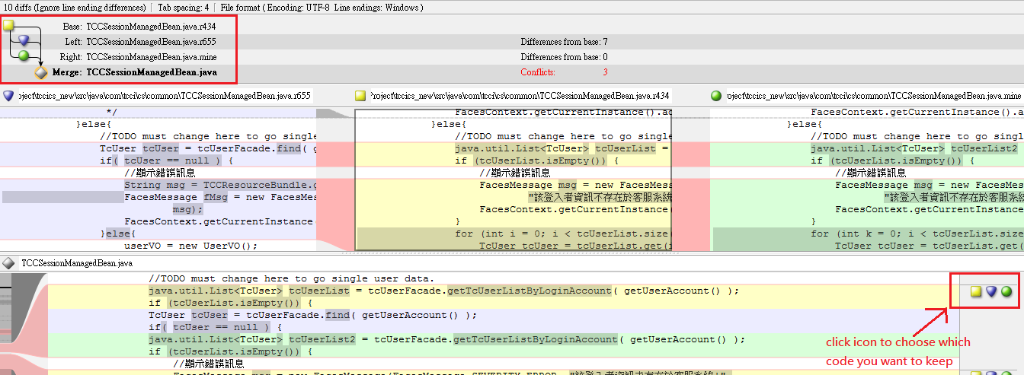

Ref

<http://1024strongoxen.blogspot.tw/2011/08/three-way-merging-made-painless-with.html>